Zoom keyboard shortcuts for iOS
If you are using an iPad with a keyboard, the following shortcuts are available in a Zoom meeting:

Action | Keyboard Shortcut
Mute/unmute my audio | Command + Shift + A
Start/Stop my video | Command + Shift + V
Display/hide chat | Command + Shift + H
Minimize meeting | Command + Shift + M
Display/hide manage participants | Command + U
Close the front window, such as the participants or meeting settings window | Command + W

Index
Most keyboard shortcuts use a combination of keys to achieve the task. In each table we have included the keyboard shortcuts for the most relevant keyboard layout. Below is an index of the alternative keys between Apple and windows keyboards.
Apple/Mac Key | Windows Key
Control | Ctrl
Option | Alt
Command (cloverleaf) ⌘ | Windows 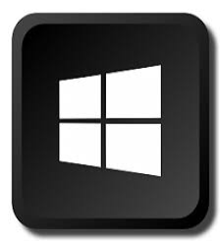
Delete | Backspace
Return | Enter

Visibility Scotland is the trading name of GWSSB (formerly Glasgow and West of Scotland Society for the Blind). GWSSB is a company registered in Scotland, limited by guarantee with its registered office at 2 Queen’s Crescent, Glasgow, being a recognised Scottish Charity. Registered number SC116552. Scottish Charity Number SC009738.

End of Document

