Android and other mobiles 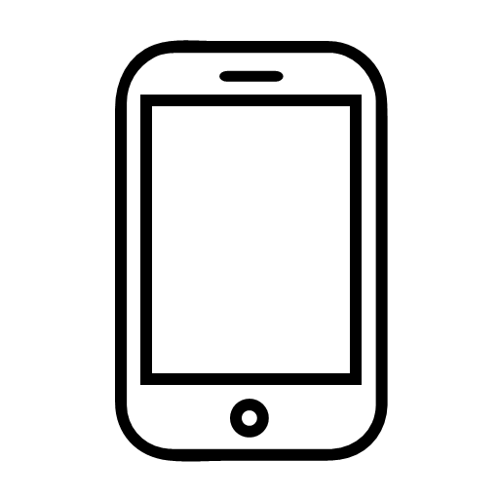
All mobile devices have accessibility options so it is worthwhile looking into this before purchasing to make sure that any potential new purchase is at least useable. The accessibility options can be found in settings, sometimes referred to as “Ease of Access”.

Big android companies such as Samsung Galaxy and Google, have developed their own accessibility options utilising their own software.

Newer higher spec models generally include the best in Android accessibility but for phones lacking in features it can also be installed as an app, the android accessibility suite.

Android Accessibility Suite
Android Accessibility Suite is a collection of accessibility apps that help you use your Android device eyes-free or with a switch device.

Android Accessibility Suite includes:
Accessibility Menu
Use this large on-screen menu to lock your phone, control volume and brightness, take screenshots, and more.
Select to Speak
Select items on your screen and hear them read aloud.
Switch Access
Interact with your Android device using one or more switches or a keyboard instead of the touch screen.
TalkBack screen reader
Get spoken feedback, control your device with gestures, and type with the on-screen braille keyboard.

Display Settings
The items and apps on screen can be enlarged as can the font size. Tap on this setting and use the scroller to adjust to your preferred size.

Magnification
Enabling magnification will allow for full screen magnification. Once activated a one finger single tap will activate - two finger pinch and open to zoom in (close to zoom out) when in magnifier mode use two finger to move around the screen.

Setting up magnification shortcut
- Settings/accessibility/magnifier.
- By default, magnifier will activate with a one finger triple tap gesture, this action can be assigned to an accessibility shortcut of your choice.
- To change your shortcut, tap Magnification shortcut, then choose one of these options:
- Accessibility button: At the bottom of your screen, tap the accessibility button.
- Hold volume keys: Press and hold both volume keys.
- Triple-tap screen: (the above default shortcut).

Zoom in temporarily
- Activate magnification with your chosen shortcut
- With one finger ouch and hold anywhere on the screen, except the keyboard or navigation bar.
- Drag your finger to move around the screen.
- Lift your finger to stop magnification.

Contrast
Use and explore the high contrast features to personalize your device. Here is where you will find inverted colour options and dark/light mode to switch between.

Voice Access
Using a wake command such as “Hey Google” lets you control your device with your voice especially useful for low vision users.
On setting up voice access the first time it is advised to follow the steps to set up “Hey Google” and also to follow the tutorial.

Switch Access
This setting lets you control your device with another method of input such as an external keyboard or a braille display with input.

Action Blocks
This customises buttons on the home screen to make regular actions easier to deliver.

Time to take action
Messages which appear on the screen only temporarily can be missed to low vision users – you can adjust how long these remain on screen here.

BrailleBack
This is Android method of connecting a Braille Display or input device to the Android phone or tablet. It works seamlessly with Talkback to provide a smooth interaction for braille users.
Android Brailleback supports most braille refreshable displays and input but tends to take longer to pick up the most recent ones (at time of writing the HumanWare Bix series is not available until later in 2021).

Visibility Scotland is the trading name of GWSSB (formerly Glasgow and West of Scotland Society for the Blind). GWSSB is a company registered in Scotland, limited by guarantee with its registered office at 2 Queen’s Crescent, Glasgow, being a recognised Scottish Charity. Registered number SC116552. Scottish Charity Number SC009738.

End of document

