Microsoft Outlook 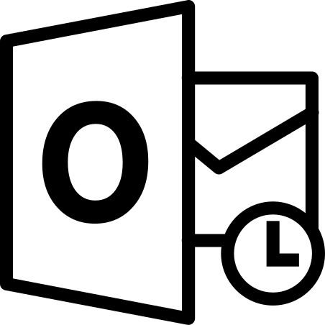

Making Email Accessible

Best Practice
- Font – use a large, clear font size and style e.g. Arial 14.
- Set font colour to automatic.
- Avoid using all capital letters, italics or underlines. Include white space between sentences and paragraphs e.g. set line spacing to 1.5.
- Keep everything left aligned.
- Maintain a logical reading order.
- Use a descriptive subject line.
- Avoid using text in images as the sole method of conveying important information. If you must use an image with text in it, repeat that text in the document.
- Add alt text to all visuals - Alt text is what someone using a screen reader will hear when navigating over an image. If the image fails to download alt text will display in its place.
- How to add alt text – In Outlook 2016 and later insert the image in your email, right click on image menu, select Format Picture, Layout & Properties. Select Alt Text and add a description of your image.
- When including links to websites or folders etc. It is best practice to use Hyperlinks rather inserting the whole URL. Make sure your hyperlink is descriptive.
- If attachments are present, advise the reader of the number and file type.
- You can request accessible content using Outlook 365.

Visibility Scotland is the trading name of GWSSB (formerly Glasgow and West of Scotland Society for the Blind). GWSSB is a company registered in Scotland, limited by guarantee with its registered office at 2 Queen’s Crescent, Glasgow, being a recognised Scottish Charity. Registered number SC116552. Scottish Charity Number SC009738.

End of document

