Microsoft PowerPoint 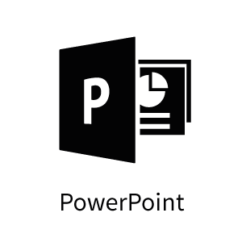

Keyboard Shortcuts

Below are the most frequently used Keyboard shortcuts for PowerPoint. To find out more shortcuts for specific actions search Microsoft support.
(https://support.microsoft.com/en-us/topic/use-keyboard-shortcuts-to-create-powerpoint-presentations-ebb3d20e-dcd4-444f-a38e-bb5c5ed180f4?ui=en-us&rs=en-us&ad=us)

Frequently used shortcuts
Action | Keyboard Shortcut
Create new presentation | Ctrl+N
Add a new slide | Ctrl+M
Make selected text bold | Ctrl+B
Change the font size for selected text | Alt+H, F, S
Open the Zoom dialog | Alt+W, Q
Cut selected text, object, or slide | Ctrl+X

Action | Keyboard Shortcut
Copy selected text, object, or slide | Ctrl+C
Paste cut or copied text, object, or slide | Ctrl+V
Undo the last action | Ctrl+Z
Save the presentation | Ctrl+S
Insert a picture | Alt+N, P
Insert a shape | Alt+N, S, H
Select a theme | Alt+G, H
Select a slide layout | Alt+H, L
Go to the next slide | Page down
Go to the previous slide | Page up
Go to the Home tab | Alt+H
Go to the Insert tab | Alt+N
Start the slide show | F5
End the slide show | Esc
Close PowerPoint | Ctrl+Q

Index
Most keyboard shortcuts use a combination of keys to achieve the task. In each table we have included the keyboard shortcuts for the most relevant keyboard layout. Below is an index of the alternative keys between Apple and windows keyboards.

Apple/Mac Key | Windows Key
Control | Ctrl
Option | Alt
Command (cloverleaf) ⌘ | Windows
Delete | Backspace
Return | Enter

Visibility Scotland is the trading name of GWSSB (formerly Glasgow and West of Scotland Society for the Blind). GWSSB is a company registered in Scotland, limited by guarantee with its registered office at 2 Queen’s Crescent, Glasgow, being a recognised Scottish Charity. Registered number SC116552. Scottish Charity Number SC009738.

End of document

