Best Start Grant

What is it?
Three payments to help parents and carers on a low income with the cost of having a child.

The three payments are:
- Pregnancy and Baby Payment
- Early Learning Payment
- School Age Payment

Am I eligible?
You may be eligible if:
- You live in Scotland
- You are pregnant or the parent or carer of a child and get certain benefits or tax credits
- It does not matter whether you are in work or not

If you are under 18 you can apply whether or not you are receiving any other benefits.

If you are 18 or 19 and do not get any benefits you can still apply if your parent or carer gets child tax credit, child benefit, universal credit child payments or the child addition of pension credit for you.

When can I apply?
You can apply for Pregnancy and Baby Payment from when you are 24 weeks pregnant up until the day your baby turns six months old.

You can apply for Early Learning Payment from when your child is two years old until they are three years and six months.

You can apply for School Age Payment during the relevant application window for your child’s age. You don’t need to take up a school place to get it.

If your child was born between 1 March 2016 and 28 February 2017, the application window to apply is from 1 June 2021 until 28 February 2022. If you wait until after then it will be too late and you will miss out on your payment.

There is no limit on the number of children you can claim each payment for.

How much will I be paid?
Pregnancy and Baby Payment is a one off payment of £606 for your first child and £303 for subsequent children. There is an extra £303 payment for a multiple birth.

Early Learning Payment is a one off payment of £252.50 around the time your child would start nursery. They do not have to attend nursery to qualify.

School Age Payment is a one off payment of £252.50 around the time your child is first old enough to start P1.

You can spend the payments on whatever you like and do not need to pay them back.

How do I apply?
You can apply:
- By phone on 0800 182 2222
- British Sign Language users can apply via video relay using the contactSCOTLAND app (visit www.contactscotland-bsl.org for more information)
- Online at www.mygov.scot/best-start
- By post – you can request a paper form by calling the above number or download and print a form from www.mygov.scot/best-start

Where can I find further information?
Further information about Best Start Foods can be found at www.mygov.scot/best-start

Many organisations provide welfare rights advice and support to apply for benefits. For details of support available in your local area please contact Visibility Scotland:
- By phone on 0141 332 4632
- By email on info@visibilityscotland.org.uk
- Visit our website at www.visibilityscotland.org.uk

We value your feedback
You can help us improve this factsheet by letting us know what you think about it. Contact us:
- By phone on 0141 332 4632
- By email on info@visibilityscotland.org.uk

Factsheet produced in collaboration with Social Security Scotland, seescape and VisionPK:
www.socialsecurity.gov.scot
www.seescape.org.uk
www.visionpk.org.uk

Visibility Scotland is the trading name of GWSSB (formerly Glasgow and West of Scotland Society for the Blind). GWSSB is a company registered in Scotland, limited by guarantee with its registered office at 2 Queen’s Crescent, Glasgow, being a recognised Scottish Charity. Registered number SC116552. Scottish Charity Number SC009738.

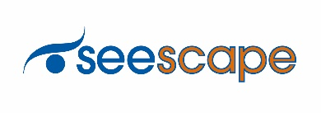
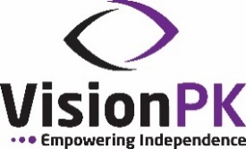
End of document

