Visibility Scotland impact report April 2024 to March 2025

Who we are
For over 165 years, Visibility Scotland has offered person-centred services to people of all ages affected by vision impairment and blindness, empowering them to reach their goals and aspirations.

Our services are co-created with their beneficiaries, using sector knowledge and data to shape service design.

Our vision: Vision impairment and blindness are understood and accepted by society.

At Visibility Scotland, our team know: you don’t need sight to have vision.

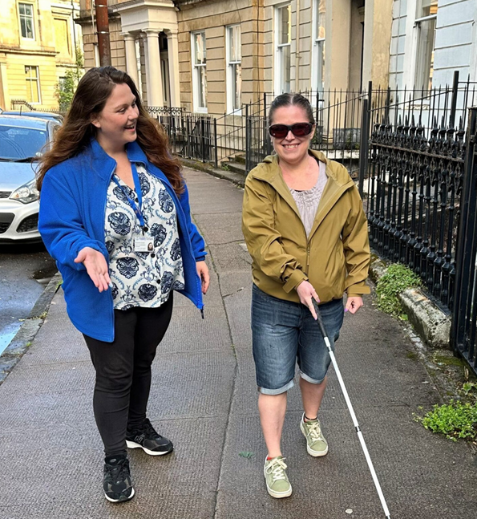
Vision Rehabilitation Specialist Sam accompanies a person practising the use of a long guide cane.

Overview of annual accounts
In the 2024-2025 financial year, our total income was £1,111,147, and our total expenditure was £1,197,643, leaving us with a deficit of £86,496.

An incredible £37,921 of our income came from charitable donations, and £191,347 from legacy donors. Thank you to everyone who supported us this past year and in all the years prior. £1,160,507 this year went directly to our charitable services. The remainder of our expenses went to our social enterprise, Visibility Trading and Training, and reflected a loss on our investments.
Ending in a deficit is not financially sustainable in the long term. However, for us, that number of £86,496 actually represents progress. Three years ago, our deficit was nearly £500,000. Each year we’ve been shrinking the gap, with the goal of breaking even by 2029.

Forging a path to fiscal sustainability
In the current funding climate, fiscal sustainability is more crucial than ever before. Visibility Scotland will strengthen long-term financial stability and resilience by diversifying income, leveraging technology, and building strategic partnerships.

We’ll continue to embrace innovation, ensuring our services remain impactful, relevant, and cost-effective. Achieving break-even is not simply a financial milestone to us; it also means independence, security, and the ability to reinvest in our mission.

By year three, our goal is to position the charity as a forward-looking, self-sustaining organisation that delivers meaningful impact while inspiring confidence in all stakeholders.

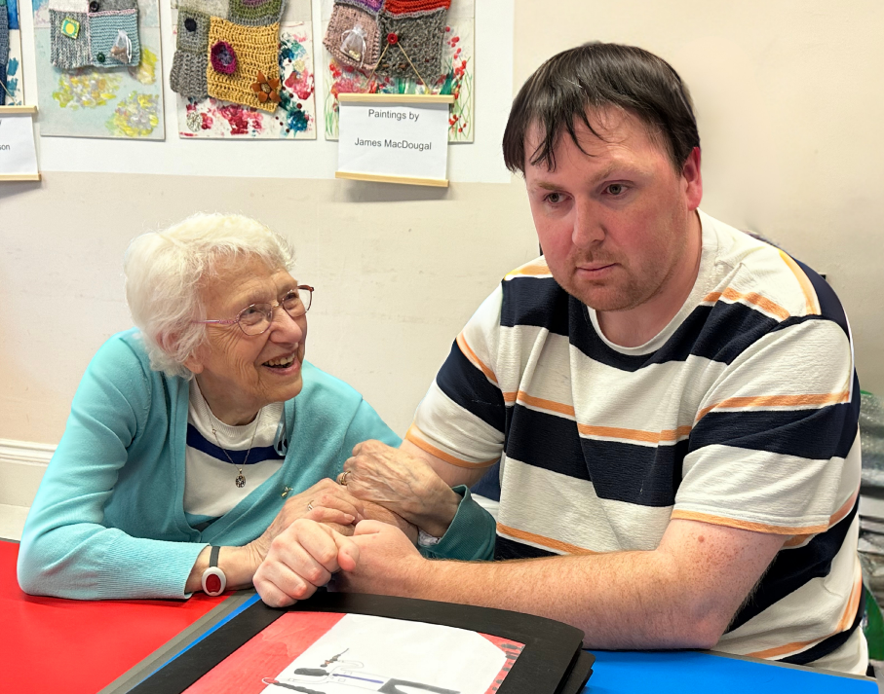
Two Visibility Scotland service users sit together. The person on the left holds the other’s arm and smiles.

Small but mighty
Our small but dedicated staff team of under 30 people directly supported over 3,000 individuals with vision impairment and blindness this past year.

3,016 people were directly supported
This number includes, but is not limited to:
- 2,063 people who accessed our Patient Support services.
- 414 people supported by our Listening Ear and Wellbeing telephone services.
- 428 people who attended one of our groups or events.

George’s path to confidence through community
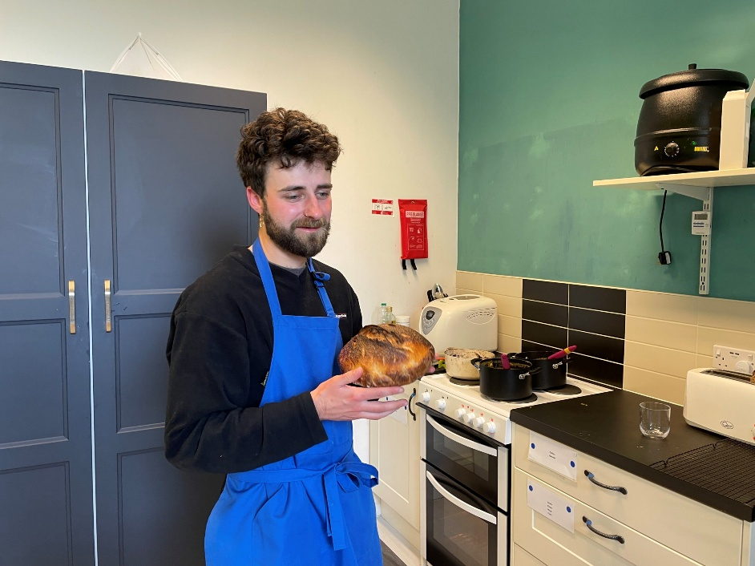
George stands holding a fresh loaf of his homemade sourdough.

George came to Visibility Scotland in 2024 feeling isolated and unsupported. He was encouraged to join the Charged-Up Café to rebuild confidence and connect with others. There, staff discovered his passion for baking and supported him to complete a Food Hygiene qualification so he could use the café kitchen.

George began baking fresh sourdough for the café and engaging socially with people of all ages. Recently, he’s taken on a volunteer role and signed up for self-defence classes with the aim of teaching others in the future.

When asked about the positive change Visibility Scotland has made in his life, George said: “I am now a volunteer at the café, and it's so good to be around people with shared experiences. Before coming to Visibility Scotland, I had never really been in the company of a blind person. I love the camaraderie, the timings work for me, it’s great for my mental health, and I feel it is good discipline to come every week. It really is the highlight of my week.”

Patient Support
Over 2,000 NHS Greater Glasgow and Clyde and NHS Lothian patients with vision impairment received emotional and practical support through our Patient Support service.

Often delivered at a time of crisis when someone has just received a difficult diagnosis, our teams offer a safe space to talk, receive information, and learn coping strategies.

Funders
- NHS Greater Glasgow and Clyde
- Edinburgh Health and Social Care Partnership
- West Lothian Health and Social Care Partnership

West Lothian Vision Rehabilitation
101 West Lothian citizens received support from our person-centred vision rehabilitation (adult) service. Our team of qualified professionals empowers people to build resilience and increase confidence by providing practical and emotional support and teaching strategies and essential skills to increase independence in the home, when out and about, in further education, and in the workplace.

Funder:
- West Lothian Health and Social Care Partnership

From isolation to inspiration: Trisha’s story
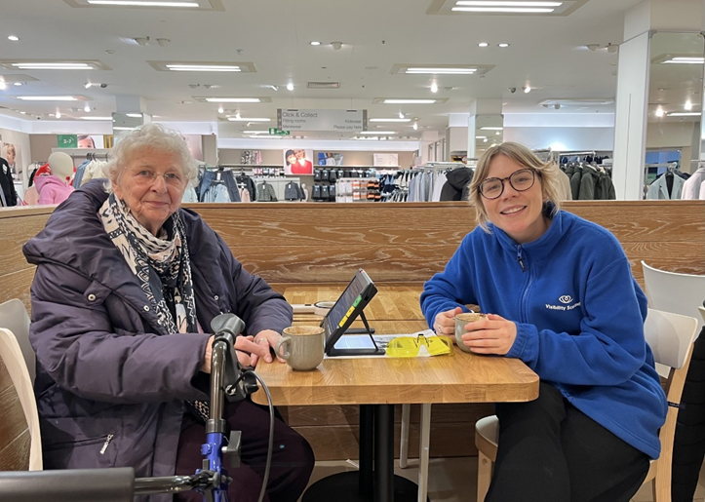
Trisha and Visibility Scotland Community Worker Steph sit together in a café. Trisha enjoys a hot drink while Steph demonstrates a digital magnifier.

Trisha found our Dumfries and Galloway service after experiencing loneliness, isolation, and reduced confidence due to Macular Degeneration and the loss of her befriender. Through tailored support, Trisha has been empowered to re-engage with meaningful experiences that bring her back to her passions.

Visibility Scotland has also helped Trisha overcome practical barriers by providing education on assistive technology and by supporting her on local outings, helping her gradually regain independence. Trisha describes the support as “absolutely wonderful,” saying, “I am really very grateful for the time you spent with me. You really reminded me of the life I have lived.”

Going forward, Trisha is excited to start an accessible yoga class and attend talks about the environment offered in her local area. Visibility Scotland will be there to support and empower her on her journey to independence every step of the way.

Community projects

Glasgow
The Glasgow Community Project helped combat loneliness and isolation for 118 Glasgow citizens with vision impairment and blindness by bringing them together to share experiences, focusing on self-management and independent living skills.

Dumfries and Galloway
The 'Out and About' project delivered person-centred one-to-one advice and support to 45 people in rural areas of Dumfries and Galloway, helping them access local amenities. This service reduces loneliness and isolation through building trusting relationships and enabling access.

Funders:
- Glasgow City Council
- Dumfries and Galloway Health and Social Care Partnership

Tech Works (digital inclusion)
Our Tech Works project provided tailored advice and demonstrations to 312 working-age people with vision impairments to help them reach their educational and employment potential through digital inclusion. Tech Works also educated employers and educational establishments on accessibility, inclusion, and reasonable adjustments.

From summer 2025 onwards, Tech Works will be replaced by the newly developed EyeT digital inclusion project, as funding for Tech Works will end.

Funder:
- The Scottish Government

New project launching in 2025: EyeCan CYP (child and family support)

EyeCan CYP (children and young people) is a brand new project starting on the first of April, 2025. In the months prior, we have reviewed and revitalised our range of holistic services for children, young people, and their families. Through our family advocacy service and comprehensive range of co-designed activities, EyeCan CYP offers skills development and support to children and young people aged 0-25, as well as their families.

Funders:
- The National Lottery Community Fund Young Start Award
- The Essentia Foundation

What our service users have to say
- “The staff are brilliant. You can relax in an environment where you’re understood. I’ve made some real friends.”
- "Visibility Scotland is one of my favourite places to go. Everyone there is friendly, funny and kind. Every time I go, I forget all my worries and just have fun.”

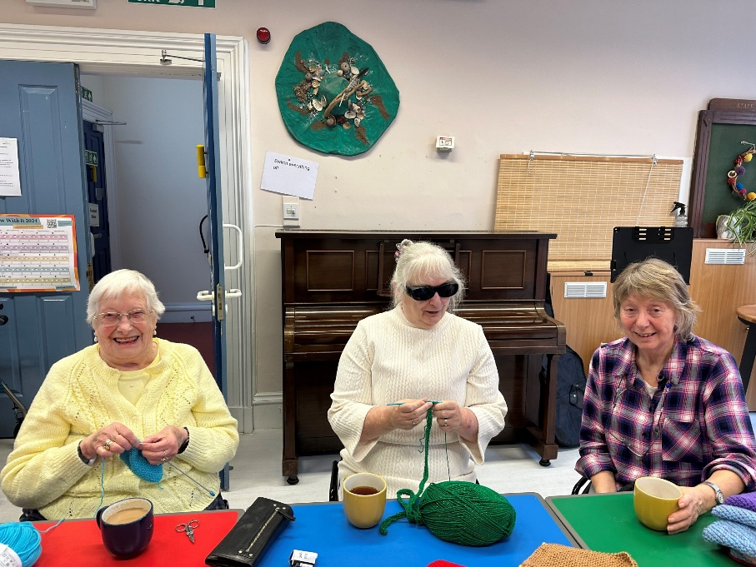
Three craft group members sit together, knitting and smiling.

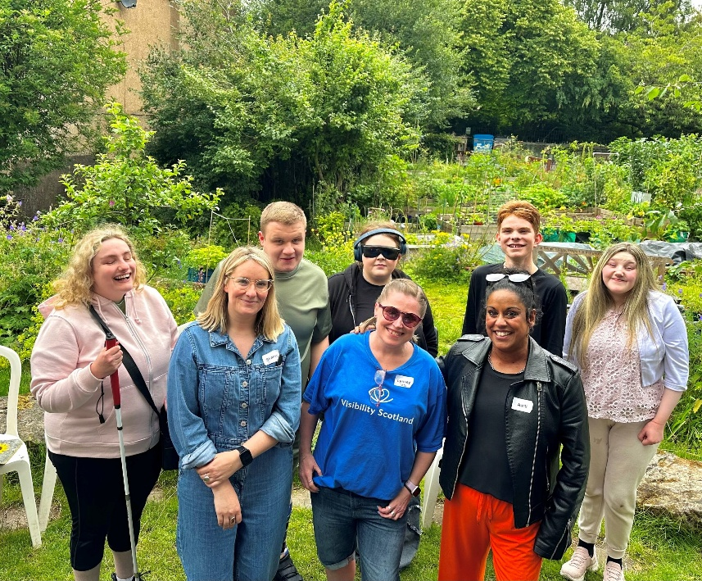
Staff and young people smile together in a garden.

Thank you
Thank you to everyone who has supported Visibility Scotland and engaged with our services over the year. As we reflect on the past, we also look forward to the future with excitement and ambition. Remember: you don’t need sight to have vision.

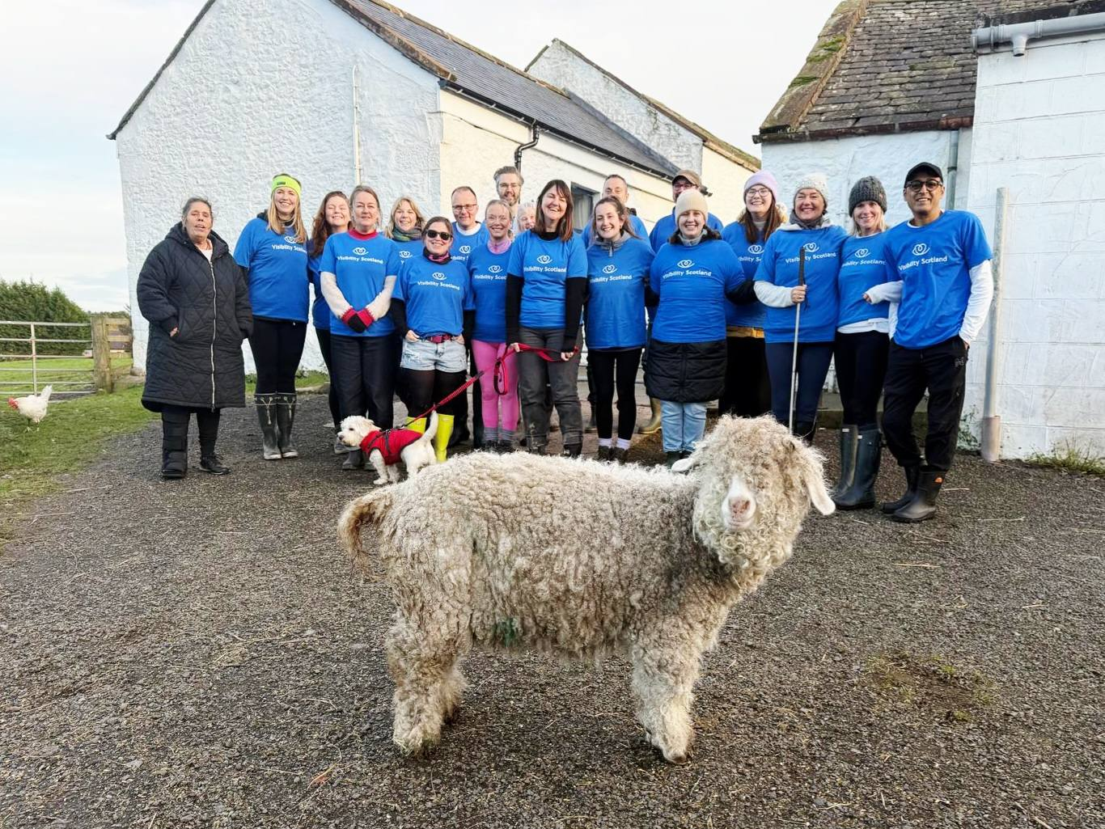
The Visibility Scotland staff team stands together smiling during a team day at Mossburn Community Farm. Lavender, the Angora goat, stands proudly in the foreground.

Visibility Scotland information
Registered Company number: SC116522
Registered Charity number: SC009738
Registered Office: 2 Queen’s Crescent, Glasgow, G4 9BW
Telephone: 0800 987 1087
Website: Visibility Scotland website

End of Document
Visibility Scotland is the trading name of GWSSB (formerly Glasgow and West of Scotland Society for the Blind). GWSSB is a company registered in Scotland, limited by guarantee with its registered office at 2 Queen’s Crescent, Glasgow, being a recognised Scottish Charity. Registered number SC116522. Scottish Charity Number SC009738.

