
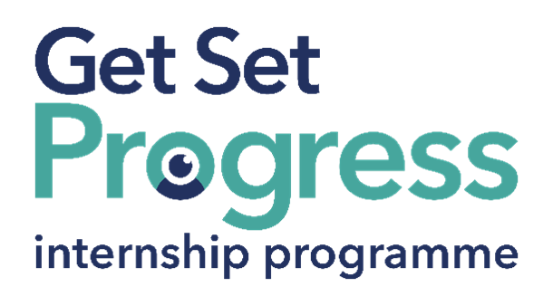

Digital Skills and Employment Advisor (Internship)

Join us at Visibility Scotland
Thomas Pocklington Trust (TPT) and RNIB are collaborating with organisations from both the sight loss and wider charity sector as well as corporate organisations to create new opportunities for blind and partially sighted people to find employment through the Get Set Progress (GSP) Internship programme. Visibility Scotland is delighted to be offering an internship as part of the Get Set Progress scheme.

About Visibility Scotland
Visibility Scotland is a national and local vision impairment charity.
Our services reduce feelings of loneliness, isolation, and loss of identity for blind and vision-impaired people through support, education, and empowerment.

At Visibility Scotland, we're more than a charity; we're a passionate, values-driven team committed to creating an inclusive world for people affected by vision impairment and blindness.
Our work is shaped by the voices, experiences, and insights of the people we support, with strong representation of lived experience throughout our organisation.

We believe in empowering people, challenging barriers and making a real difference every day. If you're looking for a role where your skills will have genuine impact, where collaboration, compassion and innovation are valued, and where you can be part of a team united by a shared purpose, we'd love to hear from you.

Our Purpose
To equip people impacted by vision impairment and blindness with the knowledge and skills to increase their confidence and achieve their goals.

Job description
Role: Digital Skills and Employment Advisor (Internship)
Reporting to: Head of Operations
Location: 2 Queen’s Crescent, Glasgow (Visibility Scotland’s HQ)
Salary: £29,797 (pro rata £23,837)
Contract type: 28 hours per week. Fixed-term, 9-month contract

Purpose of the role:
The Digital Skills and Employment Advisor will support blind and vision-impaired people in developing digital confidence, improving employability skills, and accessing opportunities for education, training, and employment.
The post-holder will draw on their lived experience and knowledge of assistive technology to empower others to overcome barriers and achieve their goals.

The Digital Skills and Employment Advisor will be based at Visibility Scotland’s headquarters. The post-holder will undertake accredited digital skills training as part of the nine-month internship.

Main responsibilities:
The post-holder will:
- Design a series of training programmes for various assistive technologies specific to acquiring digital skills for daily living and employment
- Deliver one-to-one person-centred training sessions at our Centre of Excellence and in the community
- Design and facilitate group digital skills and braille training sessions at our Centre of Excellence
- Provide consultations face-to-face and virtually
- Support and complete Access to Work applications, acting as an advocate for the vision-impaired service user
- Sell equipment
- Deliver training on inclusive practices to organisations
- Champion Human Rights

Person specification
Important information:
- This role has a Genuine Occupational Requirement that the successful applicant be a person who is blind or partially sighted, in line with The Equality Act 2010
- Interns need to be able to travel to the TPT Hub in London for development events throughout the course of the internship programme (costs covered by TPT)
- Having not previously undertaken the Get Set Progress internship programme
- Successful applicants must have the Right to Work in the UK for the duration of the Internship. Sponsorship will not be provided

Experience and Knowledge

Essential
- JAWS or NVDA users

Desirable
- Experience in teaching or mentoring
- Undertaken previous adult protection training.
- Braille reader
- ICDL certification
- Experience in working directly with vulnerable people in health and social care

Communication skills

Essential
- High degree of written and verbal skills
- Ability to communicate well with a wide range of people
- Ability to work in a team

Other Abilities and Skills

Essential
- Strong administrative skills
- Competent user of Microsoft Word, Outlook, and Excel
- Previous database or CRM experience

Desirable
- Previous experience with Microsoft Teams and Zoom
- Experience in public speaking

Personal Qualities

Essential
- A creative thinker who can think outside the box
- Socially adaptable
- Enthusiastic, demonstrating a ‘can-do attitude’
- Practical and self-motivated problem solver
- Empathetic and non-judgmental
- Organised and able to initiate and undertake tasks in complex circumstances

Closing date:
18 September 2026

How to apply
Send your accessible CV and cover letter explaining why you are the right person for this internship, together with a completed Equal Opportunities Form, to Paul Hanlon by 18th September 2026.

Email: paul.hanlon@visibilityscotland.org.uk

Interviews
Interviews will be held on 1 October at Visibility Scotland, 2 Queen’s Crescent, G4 9BW.

What are the benefits of a Get Set Progress internship for me?
As part of your 9-month internship, you will be part of a large cohort of fellow interns and gain the following:
- Obtain valuable work experience within the charity sector.
- Technology support (Including Microsoft Office) and upskilling opportunities.
- Online and in-person Training and development opportunities
- Opportunity to present and network with Senior leaders within the Sight Loss Sector
- Opportunities to build relationships with fellow interns.
- A personal mentor offering support, advice, and guidance throughout your internship.
- Help deliver positive changes for people with sight loss.

Works For Me Employment Programme
As part of the GSP Internship programme, you will also be enrolled on the TPT Works for Me Employment Programme, where you will gain bespoke employment support, guidance, and advice from the TPT Employment Team, some of the skills that you will receive support and guidance around include:
- CV writing
- Job searching
- Cover letter and speculative letter writing.
- Application form writing
- Interview techniques


Thomas Pocklington Trust (TPT) is a charity established to provide services for visually impaired people: our mission is to improve the lives of people living with sight loss.

TPT is registered with the Disability Confident Scheme as a Disability Confident employer. Therefore, we believe in treating all employees fairly, and we are committed to recruiting equally.

TPT’s charitable objective and aim is to support visually impaired individuals back into work. For this reason, we are actively seeking applications from all backgrounds, including disabled/visually impaired individuals and people who have lived experience of sight loss.

We also guarantee all disabled applicants who reach the minimum appointment criteria an interview.

We are happy to accept applications from all suitably qualified people with the appropriate skills and talent, regardless of their age, gender, race, religion, disability, sexual orientation, or marital status.
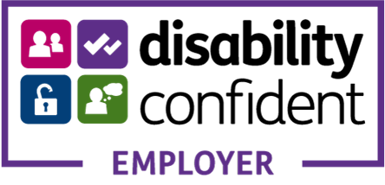

End of Document

