Visually impaired see the benefits of Meta’s glasses
Author: Tom Whipple
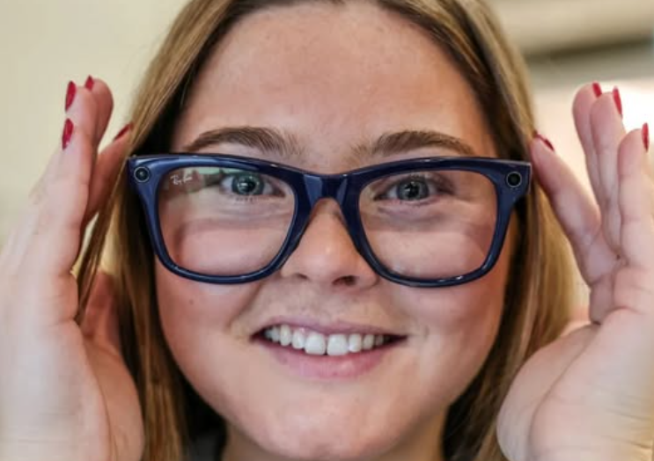
ID: Lara smiles whilst wearing Ray-Ban Metas. She is touching either side of the glasses.

For Lara Maudsley, it’s in restaurants where she notices the difference. She likes to go out for brunch but, since losing much of her vision, doesn’t like asking for help. Now she doesn’t have to.

“Instead of having to say to my friends ‘Can you read me that menu?’ I can just put the glasses on and say, ‘Tel me about the pizzas, the pastas, the avocado on toast’ and they do.” She is not alone. Other people with vision problems tell Meta they like to use its glasses to read emails at work, or describe signage while out. One said he had been able to read his own post for the first time.

This was not what the parent company of Facebook had in mind when, in 2020, it made some glasses that took pictures. Back then, the goal was for people to use the £300 specs to update their Instagram pages. “It was basically a social media tool,” said Matt Sanders from Meta.

But then they added an AI function with voice controls and started getting unexpected feedback. They had reviews not in the technology press, but from the Guide Dogs society and the American Foundation for the Blind (“There were times,” wrote the reviewer, “that I thought of them as magical”). “We realised that the blind and low vision community were some of the biggest fans” said Sanders. “We were hearing these amazing stories.”

It turns out that having a system for converting visual inputs into auditory ones is potentially nice to have if you’re a Kardashian – and life changing if you’re blind. Which is why, today, Meta finds itself working with blindness charities rather than influencers.

One of those is Visibility Scotland, which has been trialling some of the technology, helping to understand its uses and how it can be improved. “Transport is a huge one,” said August Wright, who works for the charity. “People are like, hey Meta, what number bus is approaching?” The glasses also help with work, she found. People use them for reading back documents, or even just for orientation. “You can say, ‘What office am I in front of?’ If there’s a sign on the door, it will read it.” It can spot toilets. It can also, Wright found, spot tulips. “There’s a little group of ladies, and they go over to each other’s gardens and ask it to describe the flowers, which is really cute.”

The glasses were originally introduced amid the Facebook owner’s bet on different ways to collaborate online. At the centre of this was a virtual reality “Metaverse”, which would be accessed through bulky goggles. The company lost tens of billions on that bet, but the glasses, made in partnership with Ray-Ban, have provided more solid returns.

Sanders said Meta was now “leaning in” to the growing number of applications for the visually impaired. Among the feedback they received is that they need to offer more detail.

“What we were hearing from the blind community was that it’s not enough for Meta AI to say, when asked ‘What am I looking at?’ that ‘you’re looking at a gate’” he said. “Actually, you need to know you’re looking at a kissing gate, that it’s muddy around it, that there’s a path in front that curves to the right. So you can now toggle on detailed responses to get that extra level of detail.”

It has been a year since Maudsley lost much of her usable vision after a stroke-like episode when she was 23. As well as at brunch, she uses the glasses in her day-to-day work, managing social media for Visibility Scotland. She said that in a way the glasses have helped her adjust and cope. “Not having to rely on other people is a huge thing.”

End of Document
Visibility Scotland is the trading name of GWSSB (formerly Glasgow and West of Scotland Society for the Blind). GWSSB is a company registered in Scotland, limited by guarantee with its registered office at 2 Queen’s Crescent, Glasgow, being a recognised Scottish Charity. Registered number SC116522. Scottish Charity Number SC009738.

